A000-Asia-China-Shang-Anyang period-Guang-Elephant-Bronze-c 1300-1050 BCE

SHAPE \* MERGEFORMAT 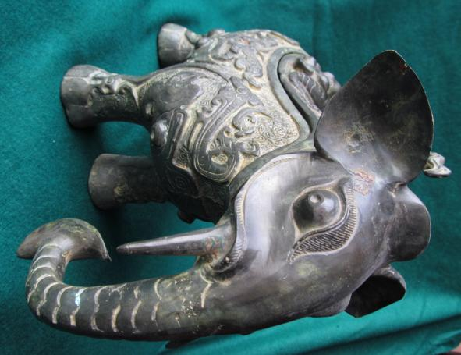

Fig. 6

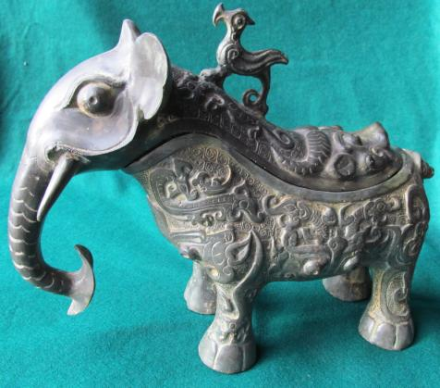

Fig. 1

SHAPE \* MERGEFORMAT 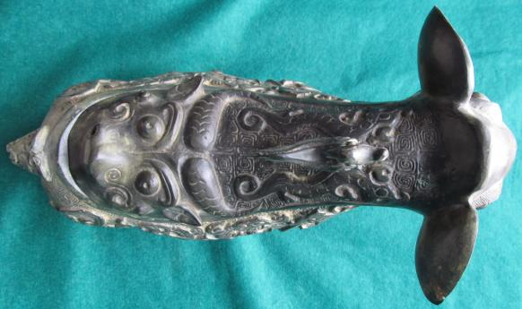

Fig. 2

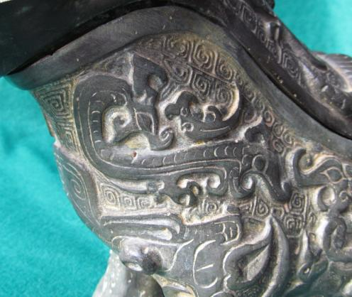

Fig. 3

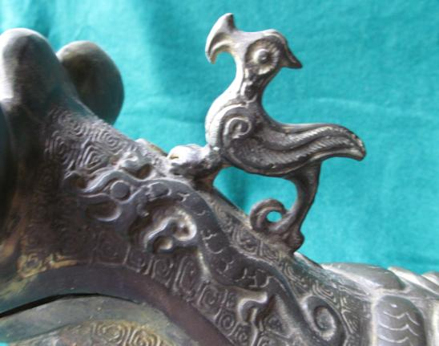

Fig. 4

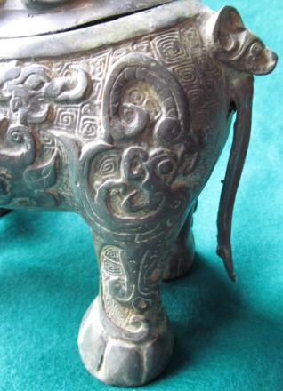

Fig. 5

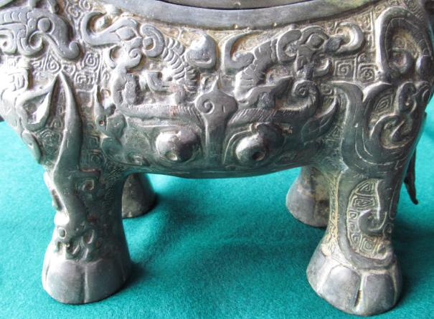

Fig. 6

China-Shang-Anyang period-Guang-Elephant-Bronze-c 1300-1050 BCE

Case No.: 5

**Accession No.**

**Formal Label:**

China-Shang-Anyang period-Guang-Elephant-Bronze-c 1300-1050 BCE

**Display Description:**

Based on the image of an elephant, as can be seen from the trunk and protruding eyes at its front, this rare example of a ritual vessel known as a guang (觥 )( *kung1*, Wade-Giles, hereinafter abbreviated "w-g"; [gōng](http://en.wiktionary.org/wiki/gōng), Pinyin, hereinafter abbreviated "p") was used to pour wine or other potent beverages from the spout of the vessel which is in the form of the head of the creature whose mouth constitutes the end of the spout. *Guang* were used in ceremonies linking the rulers of the Shang dynasty (ca. 1600-1050 BCE) with their ancestors and supernatural forces. The metaphoric imagery that defines this vessel typifies bronzes cast at the late Shang (ca. 1300-1050 BCE) at the capital of Anyang, Henan Province, in north-central China.

The late Shang (ca. 1300-1050 BCE) time horizon coincides with the Indo-European invasions of the sub-continent of India and the western regions of the Silk Road in what is known as Xinjiang Autonomous Province of P. R. C. but was then known as Sinkiang and was infiltrated during the second millennium by Uyghurs (Turkic Mongolians from Mongolia). During this period influxes of Indo-Europeans from the area adjacent to the Black and Caspian Seas also penetrated Sinkiang. The result was an admi8xture of Mongolian and Indo-Europeans that is represented in the mummies of Cherchen which lies on the southern Silk Road route.

The first radical of *guang* "角" refers to an ancient drinking vessel made from the horn of an animal that is obvious in its oracle-bone script radical of a pointed horn. In Indo-European languages this ancient vessel type was called a rhyton, ῥυτόν in ancient Greek is from Greek *rhein*, "to flow" (Liddell and Scott 1940) which is from the proto-Indo-European*\*sreu-*, "flow" (Pokorny 1959: 1003), which is the root of *rhutos,* "stream," and in its neuter form, *rhuton*, which is the vessel used to pour. The combination of a vessel connected with the act of flowing fluid and an animal's head as its vehicle may have ancient connections with the Chinese Shang *guang,* becausethe spout of the *guang* is in the form of the head of the creature whose mouth constitutes the end of the spout which is associated with flowing fluid. Furthermore the horned water-buffalo-like creature on the rump of the elephant suggests a connection with the ancient oracle -bone script radical as a pointed horn



Fig.7. Horned creature.

In addition, the creatures on both the second millennium *rhyta* and the *guang* are fantastic. In Persia they are often griffins or other imaginary creatures. In Shang China the creatures portrayed suggest a correspondence with the fantastic animals of the Shan Hai Jing (山海經) or "Classic of the Mountains and Seas," a 4th century BCE folkloric, geographical, natural historical and mythological collection based on ancient records no longer extant (see Anon. in "References" below). The Shan Hai Jing provides a sourcebook of the Chinese predilection for the fantastic, whether it be animals or geographical oddities as they are related to the belief in the principle of Shang Ti (上帝) or "Celestial Ruler" of the universe. Shang Ti (w-g) (Shang Di, p) as cited in the Shang period oracle bone inscriptions, presided over a hierarchy of lesser deities of which these *guang* vessels may represent as their earthly images. Since *guang* vessels were used to dispense psychoactive substances in ceremonial settings, it is possible that they represented the vehicles that commuted Shang Ti's visions of the celestial world in both its mythical and moral dimensions to His believers.



Fig. 8. Thundercloud motifs (leiwen).

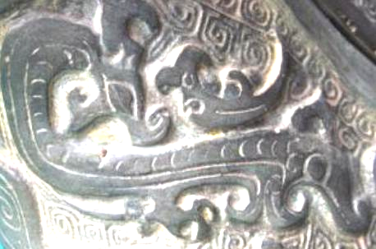

Fig. 9. Dragon motif on throat.

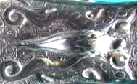

Fig. 10. Dragon motifs on lid.

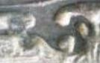

Fig. 11. Dragon with 5 claws.

The idea of these *guang* as visions of the celestial world is reinforced by the low-relief background of linked spirals known as thundercloud motifs (leiwen) as seen in the figures below. Dragons are strategically placed both on the throat of the vessel, the body of the vessel and the vessel's lid, thereby encompassing both parts of the vessel. The dragon in Shang times was associated with rain and the Yang principle, and those with five claws as shown in Fig. 6 were considered to be Imperial creatures and associated with immortality. This suggests that the imagery of the dragons was a medium by which immortality or the vision of such) was commuted to those participating in the libations. Fig. 6 shows two rampant dragons that form the upper part of a beautifully stylized a *taotie* (monster mask) frieze on the body of the vessel with two protruding eyes below.

**LC Classification:**

**Date or Time Horizon:**

**Geographical Area:**

Possibly Anyang, Henan Province, China

**Map:**

**GPS coordinates:**

**Cultural Affiliation:**

**Media:**

**Dimensions:** 14.7 in. (37.4 cm) long, 9.5 in. (24.1 in. high)

**Weight:**

**Condition:**

**Provenance:**

**Discussion:**

The Chinese were one of the first cultures to develop sophisticated bronze casting technology, and they did it in a unique way. This *guang* was cast using several ceramic piece-molds, a method that has no ancient parallel: ceramic molds carved with complicated multilayered designs were assembled around an interior clay core and then hardened. Molten bronze (with varying percentages of tin added to copper) was poured into the cavity between the core and the mold. Once the bronze had cooled and hardened, the exterior ceramic molds were broken to reveal the vessel. Several components were essential to the successful production of bronze vessels in this manner: the availability of mined and processed metals, skilled clay sculptors, and knowledgeable metallurgists.

**References:**

Anon. [4th cent BCE]. Shan Hai Jing. (山海經) or "Classic of the Mountains and Seas." There is one translation by Ann Birrell into English (Birrell, Anne. 2000. *The Classic of Mountains and Seas*. London: Penguin) which is meant for a popular audience but is unusable for scholarly purposes since it lacks Chinese transliterations of names, which Birrell has so fancifully translated that reverse translations are impossible. An exposition of the bestiary portion has been produced by Richard E. Strassberg with illustrations (Strassberg, Richard. 2002. *A Chinese Bestiary: Strange Creatures from the Guideways Through Mountains and Seas.* Los Angeles: University of California Press). Rémi Mathieu's French translation is the best available in a critical edition with an accompanying glossary and index. This unfortunately was produced in a limited 2 v. edition (*Etude sur la mythologie et l'ethnologie de la Chine ancienne* [Paris] : Collège de France, Institut des hautes études chinoises, Diffusion De Boccard, 1983. Mémoires de l'Institut des hautes études chinoises, v. 22). A massive, three volume Chinese edition is the best for its completeness of text. (Yang, Shoujing, 1839-1915, ed. 1989. Shan Hai Jing (山海經). Shui jing zhu shu. [Nanjing] : Jiangsu gu ji chu ban she,. 3 v.: [45], 3508, 62 p.)

Liddell, Henry George; Scott, Robert. 1940. "ῤυτὀν". *A Greek-English Lexicon. Revised and augmented throughout by Sir Henry Stuart Jones with the assistance of Roderick McKenzie*. Oxford: Clarendon Press.

Pokorny, Julius. 1959. ["sreu"](http://archive.org/stream/indogermanisches03pokouoft" \l "page/1002/mode/2up). *Indogermanisches etymologisches Wörterbuch*. Bern: Francke.